**Name: ____________________________________ Id: ______________**

1. Determine the representation of ( 93)10 using the following code 7421 (1)

|  |
| --- |
|  |
|  |
|  |
|  |

1. Add the following two BCD numbers, (0101 1000 0110) + (0110 0001 0110) (3)

|  |
| --- |
|  |
|  |
|  |
|  |
|  |
|  |
|  |
|  |
|  |

1. Calculate the propagation delay of the following logic diagram (1)

Knowing the propagation delay of the following gates: NOT gate=3nsec AND gate & OR gate=10 nsec NAND gate & NOR gate=13 nsec XOR gate=20nsec XNOR gate=23 nsec

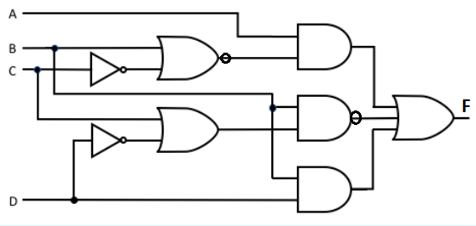

1. Draw the logic diagram for the following function after simplification using k-map,

F(A,B,C,D)= m(0,1,4,5,12,13)+d(6,7,14,15) as PoS (5)

|  |
| --- |
|  |
|  |
|  |
|  |
|  |
|  |
|  |
|  |
|  |

|  |
| --- |
|  |
|  |
|  |
|  |
|  |
|  |
|  |
|  |
|  |

|  |
| --- |
|  |
|  |
|  |
|  |
|  |
|  |
|  |
|  |
|  |
|  |
|  |
|  |